Blundells Cottage Couch Driver Information
Blundells Cottage is an external program offered by the National capital Authority. The following document is to be provided to the coach driver.

Bus Drop off and Pick up Location:
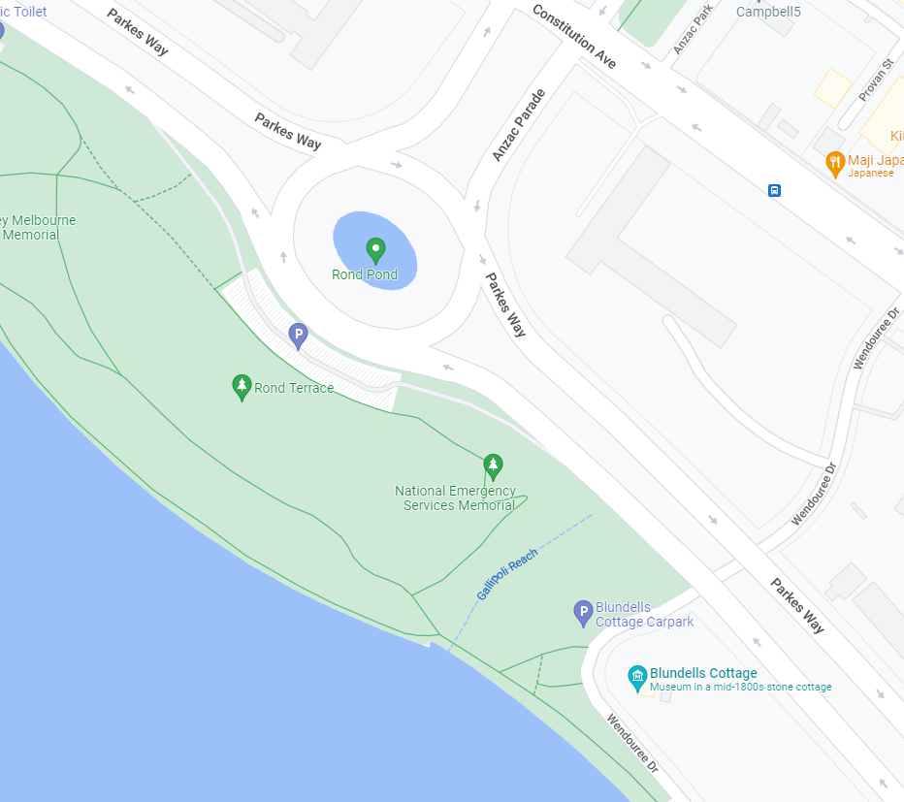
Bus Drop off/Pick up Location Option 1
Bus Drop off/Pick up Location Option 2
Starting Location | Blundells Cottage
Bus Parking | Option 1: Blundells Cottage – Wendouree Dr, Parkes 2600  Option 2: Rond Terrace, parking
On-Day-Contact | NCE Booking Line – 02 6272 2902
Please note | - If a group does not give prior notification and is more than 15 minutes late for the starting time, this booking will be cancelled. If your group is running late, please notify the NCE as soon as possible on 02 6272 2902.  - Walking shoes, sunscreen, hat and water bottle recommended.  - There are no public toilets available.  - Blundells is not wheelchair accessible. Please contact us if there are any mobility concerns for your group.

