ANZAC Parade Guided Walking Tour

Information and Maps

On site Contact | National Capital Exhibition: 02 6272 2902  Please ensure this sheet is given to the bus driver and lead teacher for this walking tour.
Drop off Location | 55 Anzac Park, Reid ACT 2612. i.e., corner of ANZAC Park Road and Elimatta Street near Reid Oval, see the page 2.
Tour Start Location | Meet behind the Australian Hellenic War Memorial (Red Star on Map).
Pick up Location | Same as drop off.
Please note | - If a group does not give prior notification and is more than 15 minutes late, this booking will be cancelled at the discretion of the guide. Please also be aware that any lateness will shorten the tour, as we cannot change the finishing time.  - Walking shoes, water bottle, sunscreen and hat are highly recommended and warm clothes during winter.  - There are no public toilets available on this Walking Tour.  - This Walking Tour requires the crossing of roads.  - This Walking Tour is wheelchair accessible BUT requires some adjustment. Please contact us if there are any mobility concerns for your group.  - Walking Tours will not go ahead in cases of extreme weather such as high temperatures or heavy rain - tours will continue in light rain at the discretion of the tour organiser and on the day teacher. Optional weather contingencies are possible depending on availability.

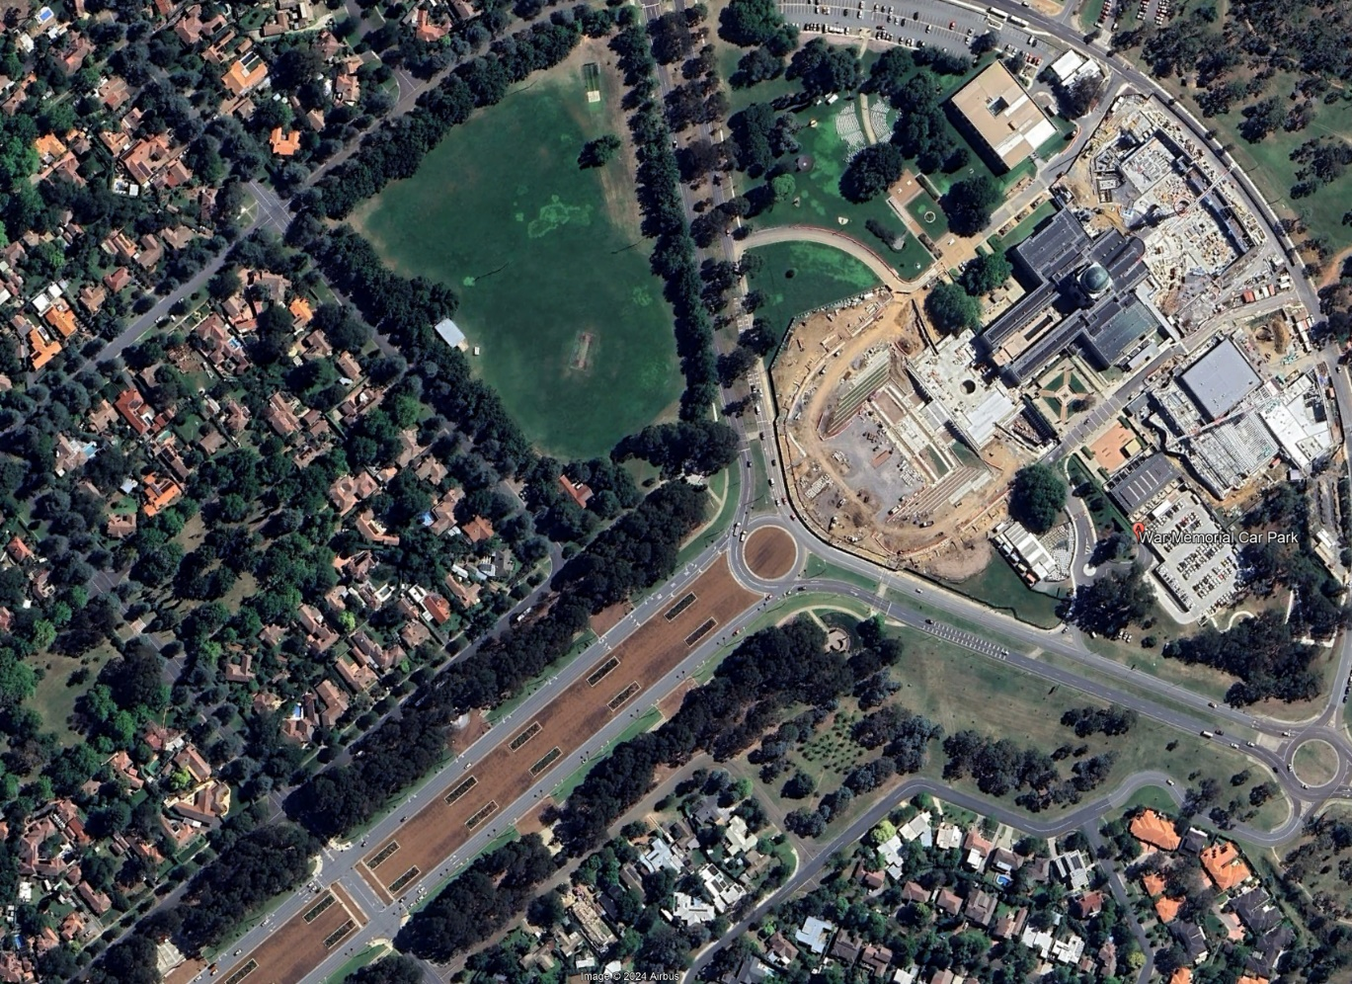
Image 1: Bird's eye view of tour start location.

Elimatta St
War Memorial

ANZAC Park Rd

ANZAC Parade

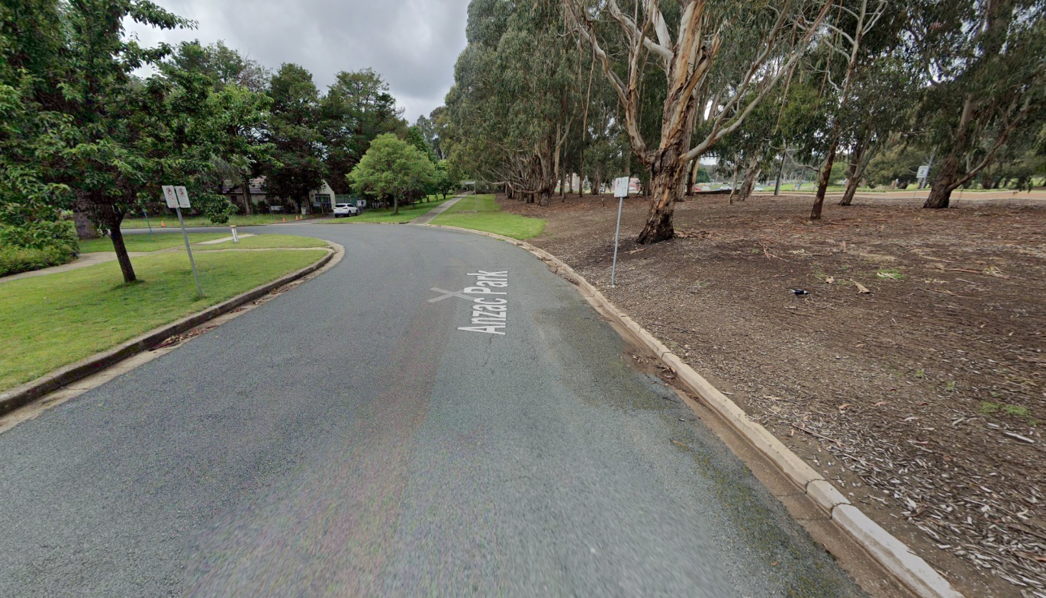

Hellenic Memorial
Elimatta Street

Image 2: Streetview of tour start location.
ANZAC Park

BUS PARKS HERE

