Lake Burley Griffin Education Program

Information and Maps
The National Capital Authority offers guided external education programs (walking tours) of Lake Burley Griffin. This document is to be provided to the coach driver before the program.

On site Contact | National Capital Exhibition: 02 6272 2902  Please ensure this sheet is given to the coach driver and lead teacher for this walking tour.
Drop off location | Parking in National Capital Exhibition Carpark, Regatta Point
Tour Start Location | Outside entry of National Capital Exhibition, Regatta Point
Pick up location | Blundells Cottage Carpark, Wendouree Dr, Parkes. NOTE: 4.2m Low Clearance  Or  Rond Terrace (no clearance)
Please note | - If a group does not give prior notification and is more than 15 minutes late, this booking will be cancelled at the discretion of the guide. Please also be aware that any lateness will shorten the tour, as we cannot change the finishing time.  - Walking shoes, water bottle, sunscreen and hat are highly recommended and warm clothes during winter.  - The are public toilets available at the National Capital Exhibition. If tour participants would like to use them, please arrive early.  - This Walking Tour is wheelchair accessible BUT requires some adjustment. Please contact us if there are any mobility concerns for your group.  - Walking Tours will not go ahead in cases of extreme weather such as high temperatures or heavy rain or - tours will continue in light rain at the discretion of the tour organiser. Optional weather contingencies are possible depending on availability.

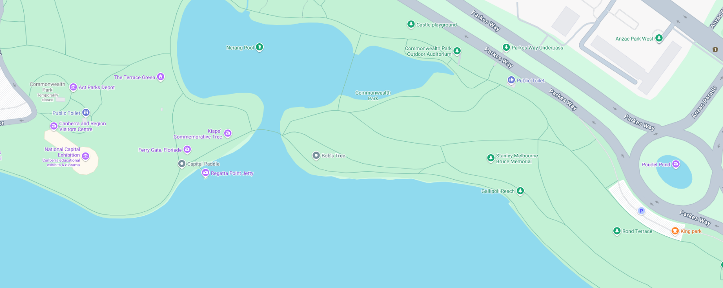

Drop off location

Pick up location

Image 1: Bird’s eye view of the drop off and pick up location for the tour

Alternate Pick-Up Area

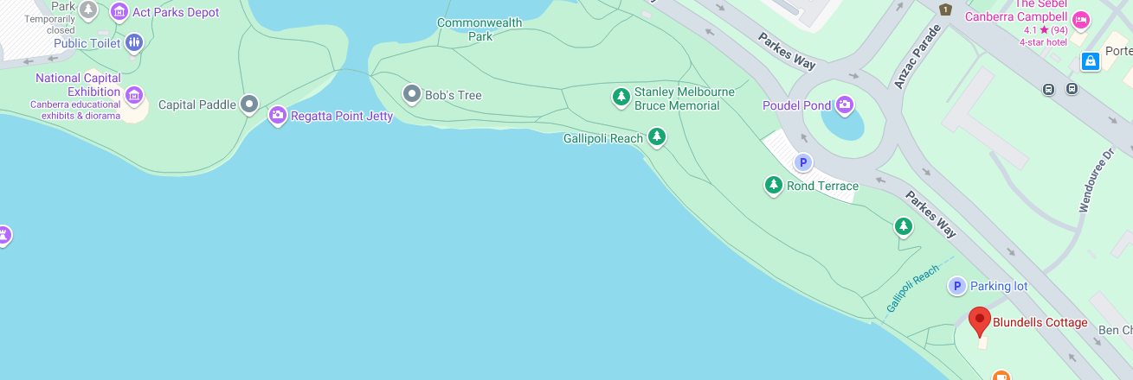
Image 2: Bird’s eye view of the drop off and the alternate pick up location for the tour
Drop off location
Pick up location

