Reconciliation Place Education Program

Information and Maps
The National Capital Authority offers guided external education programs (walking tours) of Lake Burley Griffin. This document is to be provided to the coach driver before the program.

On site Contact | National Capital Exhibition: 02 6272 2902  Please ensure this sheet is given to the coach driver and lead teacher for this walking tour.
Drop off Location | Questacon Picnic Shelter. See map on page 2.
Tour Start Location | Questacon Picnic shelter, Mall Rd West, Parkes (Red Arrow on Map)
Pick up Location | Same as drop off.
Please note | - If a group does not give prior notification and is more than 15 minutes late, this booking will be cancelled at the discretion of the guide. Please also be aware that any lateness will shorten the tour, as we cannot change the finishing time.  - Walking shoes, water bottle, sunscreen and hat are highly recommended and warm clothes during winter.  - There is a public toilet located next to the start location, but please ensure additional time is allowed before the start of the tour if a toilet break is required.  - This Walking Tour requires the crossing of roads.  - This Walking Tour is wheelchair accessible.  - Walking Tours will not go ahead in cases of severe weather such as heavy rain or high temperatures. Tours will continue in light rain at the group organiser’s discretion. Optional weather contingencies are possible depending on availability.

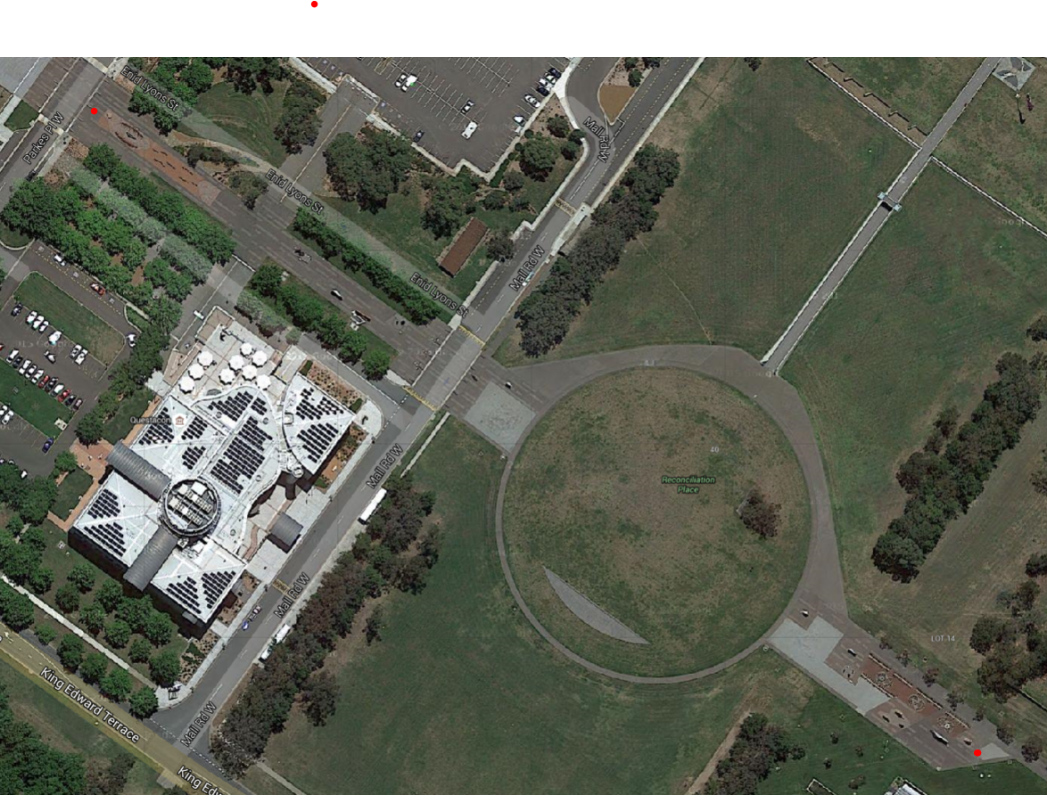
Drop off location

Image 1: Bird's eye view of drop off location and tour start location. The crosses represent both ends of Reconciliation Place.
King Edward Terrace

Questacon

Tour Start Location
Starting Point
(Parkes Place West)
Finishing Point
(Parkes Place East)

